The name of the cohort: ClubLinkers

The description of the Mini-World: Comet Connect!

Welcome to Comet Connect, the University of Texas at Dallas club hub app! This app is your gateway to
exploring and engaging with a diverse array of clubs, each hosting exciting events on campus.
Whether you're a student (undergraduate or graduate) or an employee (staff, faculty, or club faculty), the app simplifies the process of subscribing to clubs that match your interests. Once subscribed, you can actively participate by making posts within the app, and these posts will be stored in dedicated discussion forums created by the clubs.

Discover an array of events organized by clubs, such as workshops, community service activities,
seminars, and social gatherings. What makes Comet Connect special is the active involvement of club
faculty who not only guide but also host the clubs. Students and employees have the opportunity to
transition into club faculty, and employees, including staff and faculty, can become integral members of
the hosting process.

Comet Connect is more than just an app; it's a dynamic platform designed to bring the university
community together. Explore, engage, and connect through clubs, events, and discussions—all
conveniently accessible through the Comet Connect app. It's your go-to space for fostering a sense of
community and staying actively involved in campus life.

EER Diagram:

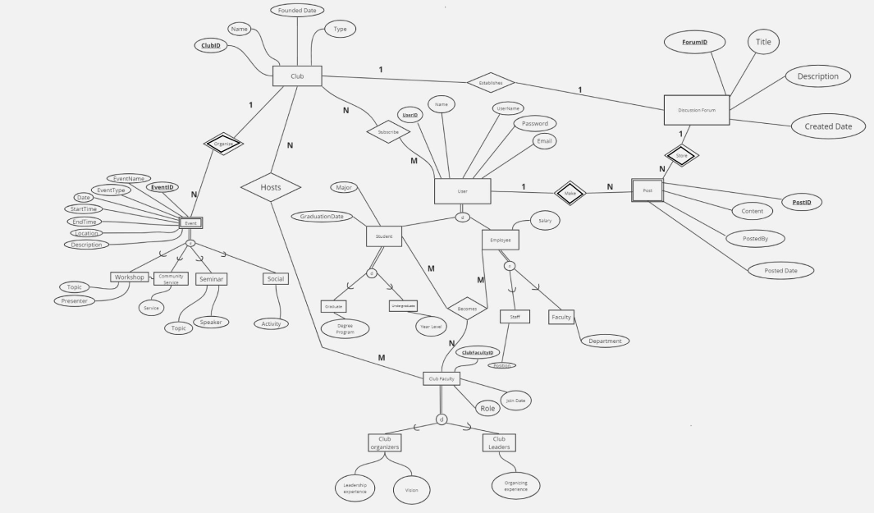

Assumptions:

Even though the hosts of the clubs can be considered employees, we chose to make a new entity called
club faculty, which students and employees can both join. We assume that club hosts are not considered
employees of the university.

In this mini-world, only clubs are allowed to organize events, making the event entity a weak entity.
Even though users are both employees and students, we choose to add a subscribe relationship between
users and the club since some users will subscribe to the club and become members or branch off to
become leaders/organizers.

When a club is made, the club can choose to establish a forum to keep communication with users there.
Users (which include club faculty) can post to the forum. A post cannot exist if there are no users to post it or if there is no forum to post on, making it a weak entity.

The Entity Dictionary:

Club:
Description: An organization within the university that hosts events and has members.

Attributes:
- ClubID: Integer, an identifying number for the club
- Name: Varchar(80), the name of the club
- Type: Varchar(50), the type of the club (e.g., academic, social, sports, etc.).
- FoundedDate: Date, the date when the club was founded
- Primary Key: ClubID

Club Faculty:
Description: A connection between students, clubs, and faculty.

Attributes:
- ClubFacultyID: Integer, a unique identifier for the ClubFaculty relationship.
- Role: Varchar(20), specifies the role of the user in the club (e.g., member, organizer)
- JoinDate: Date, the date when the user joined the club
- Primary Key: ClubFacultyID

Club Leaders:
Description: The user leaders of which clubs.

Attributes:
- Organizing Experience: Integer, experience in organizing club activities.
- Primary Key: Inherits ClubFacultyID from superclass Club Faculty

Club Organizers:
Description: The user organizers of which clubs.

Attributes:
- Leadership Experience: Integer, experience in leadership roles.
- VisionForTheClub: Text, vision for the club's future and direction.
- Primary Key: Inherits ClubFacultyID from superclass Club Faculty

Community Service:
Description: The club faculty hosts a community service for the club.

Attributes:
- Service: Varchar(20), specifies what the service will be
- Primary Key: Inherits EventID from superclass Event

Discussion Forum:
Description: A digital platform designed for engaging users in online discussions

Attributes:
- ForumID: Integer, an identifying number for the discussion forum
- Title: Varchar(100), the title of the forum
- Description: Text, a brief description of the forum's purpose
- CreatedDate, Date, the date when the forum was created
- Primary Key: ForumID

Employee:
Description: Employees within the club/university application system.

Attributes:
- Salary: Integer, the salary of the employee.
- Primary Key: Inherits UserID from superclass User

Event:
Description: Various events organized within the university by clubs.

Attributes:
- EventID: Integer, an identifying number for the event
- EventName: Varchar(80), the name of the event
- EventType: Varchar(20), specifies the type of event (workshop, seminar, social, etc.)
- Date: Date, the date of the event
- StartTime: Time, the start time of the event
- EndTime: Time, the end time of the event
- Location: Varchar(100), the location where the event will be held
- Description: Text, a brief description of the event
- Primary Key: EventID inherits from weak entity

Faculty:
Description: Faculty members of the university.

Attributes:
- Department: Varchar(50), the department where the faculty member works
- Primary Key: Inherits UserID from superclass User

Graduate:
Description: Graduate students within the university.

Attributes:
- DegreeID: Integer, the degree program the graduate student is enrolled in.
- Primary Key: Inherits UserID from superclass User

Post:
Description: User-generated posts within the university's club application.

Attributes:
- PostID: Integer, an identifying number for the post
- Content: Text, the content of the post
- PostedBy: Integer, the ID of the user who posted the post
- PostedDate: Date, the date when the post was created
- Primary Key: PostID

Seminar
Description: A type of event representing seminars organized by clubs.

Attributes:
- Topic: Varchar(100), the topic of the seminar
- Speaker: Varchar(100), the name of the speaker/presenter
- Primary Key: Inherits EventID from superclass Event

Social:
Description: A type of event representing social gatherings organized by clubs.

Attributes:
- Activity: Varchar(100), the activity planned for the social event
- Primary Key: Inherits EventID from superclass Event

Staff:
Description: Staff members of the university.

Attributes:
- Position: Varchar(50), the position/title of the staff member
- Primary Key: Inherits UserID from superclass User

Student:
Description: Students enrolled in the university.

Attributes:
- Major: Varchar(50), the major of the student
- GraduationDate: Date, the expected graduation date of the student
- Primary Key: Inherits UserID from superclass User

Undergraduate:
Description: Undergraduate students within the university.

Attributes:
- YearLevel: Integer, the current year level of the undergraduate student
- Primary Key: Inherits UserID from superclass User

User:
Description: Users of the club application within the university.

Attributes:
- UserID: Integer, a unique identifier for the user
- Name: Varchar(100), the first name of the user
- UserName: Varchar(80), the username of the user
- Password: Varchar(50), the password of the user
- Email: Varchar(100), the email address of the user
- Primary Key: UserID

Workshop:
Description: A type of event representing workshops organized by clubs.

Attributes:
- Topic: Varchar(100), the topic of the workshop
- Presenter: Varchar(100), the name of the presenter/organizer
- Primary Key: Inherits EventID from superclass Event

Positions:
Description: Manages information about different positions or titles within an organization.

Attributes:
● PositionID: Integer, the unique identifier for a each position.
● Name: Varchar(50), the position/title of the staff member
● Description Varchar(100) : A brief description of the position/title
● Primary key: PositionID

Departments:
Description: Manages information about various departments within the institution

Attributes:
● DepartmentID: Integer, the unique identifier for a club.
● Name: Varchar(50), the department where the faculty member works
● Description Varchar(100) : The description of the department
● Primary key: DepartmentID

DegreeProgram:
Description: Manages information about academic degree programs

Attributes:
● DegreeID: Integer, the unique identifier for a degree.
● Name: Varchar(50), the name of the degree program
● Primary key: DegreeID

Relation Dictionary:

Relationship: Becomes

Description: Students or employees become faculty members of one or more clubs. Each club can have

one or more students or employees becoming faculty. Clubs can have faculty members without any

student or employee becoming faculty, but each student or employee can only become a faculty member

of the clubs they are affiliated with.

Entities: Student, Employee, Club Faculty

Cardinality: Many Students to Many Clubs

Participation: Partial-to-Partial

Relationship: Establishes

Description: Clubs establish one discussion forum. Each discussion forum is established by one club.

Discussion forums can exist without being established by a club; clubs can exist without establishing

discussion forums.

Entities: Club, Discussion Forum

Cardinality: One Club to One Discussion Forum

Participation: Partial-to-Partail

Relationship: Hosts

Description: Clubs are hosted by students or faculty members. A student or faculty member can host one

or more clubs.

Entities: Club, User (Student, Faculty)

Cardinality: Many Users (Students, Faculty) to Many Clubs

Participation: Partial-to-Partial

Relationship: Makes

Description: Each user can make one or more posts, and each post can be made by one or more users.

Users may exist without making any posts, and posts may exist without being made by any user, but each

post must be associated with at least one user, and each user may contribute to multiple posts.

Entities: User, Post

Cardinality: Many Users to Many Posts

Participation: Partial-to-Total

Relationship: Organizes

Description: Clubs organize one or more events. Events must be organized by one club. Events cannot

exist without being organized by a club; clubs can exist without organizing events.

Entities: Club, Event

Cardinality: One Club to Many Events

Participation: Partial-to-Total

Relationship: Stored

Description: Posts are stored in one discussion forum. A discussion forum contains one or more posts.

Posts cannot exist without being stored in a discussion forum, as there needs to be a place to post them.

However, a discussion forum can exist without containing any posts.

Entities: Post, Discussion Forum

Cardinality: One Discussion Forum to Many Posts

Participation: Total-to-Partial

Relationship: Subscribes

Description: Users subscribe to one or more clubs. Clubs have one or more subscribers. Users can exist

without subscribing to any club; clubs can exist without having any subscribers.

Entities: User, Club

Cardinality: Many Users to Many Clubs

Participation: Partial-to-Partial

Relation Schema Diagram:

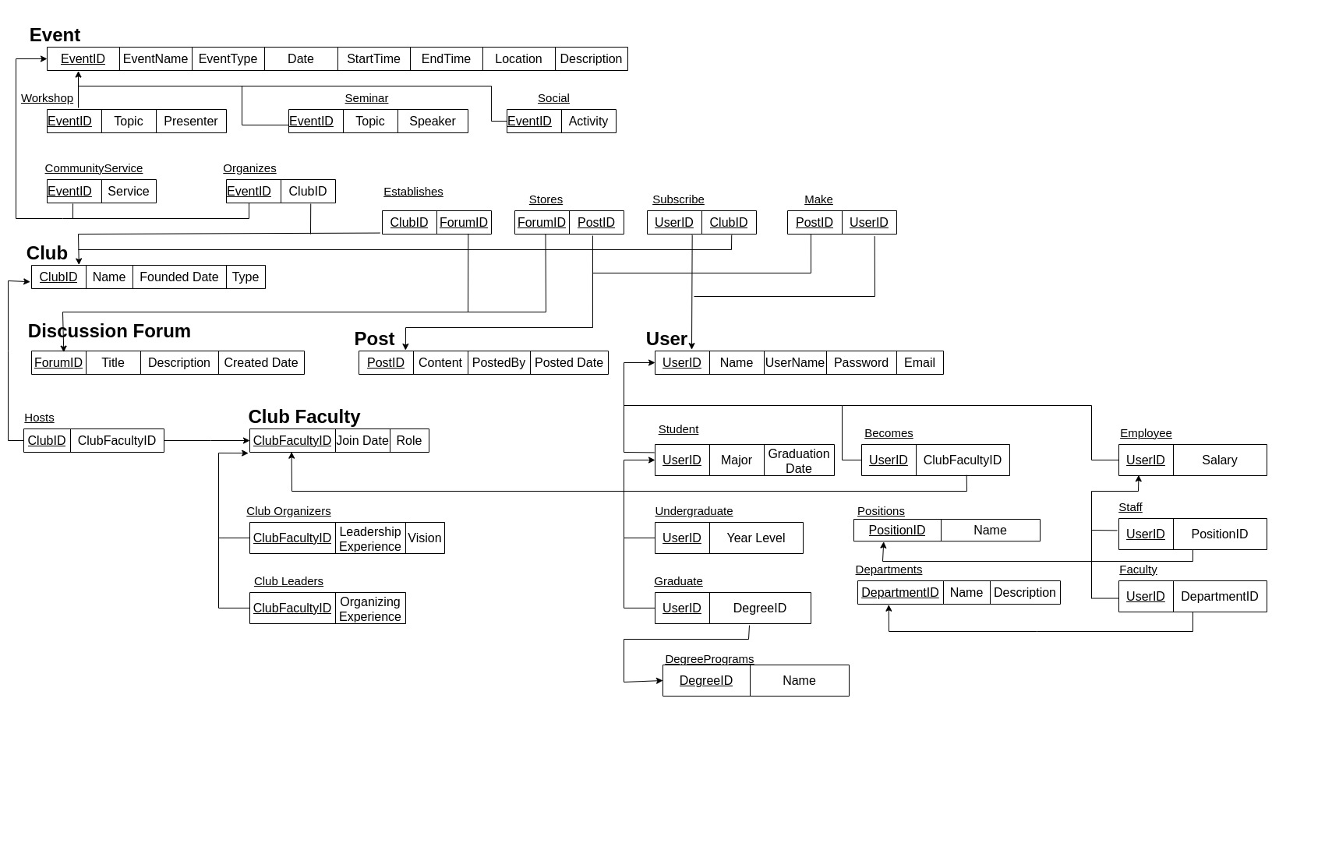

Relational Schema Dictionary:
Club:
Description: An organization within the university that hosts events and has members.
Attributes:
● ClubID: Integer, an identifying number for the club
● Name: Varchar(80), the name of the club
● Type: Varchar(50), the type of the club (e.g., academic, social, sports, etc.).
● FoundedDate: Date, the date when the club was founded
Primary Key: ClubID

Club Faculty:
Description: A connection between students, clubs, and faculty.
Attributes:
● ClubFacultyID: Integer, an identifying number for the Club Faculty.
● Role: Varchar(20), specifies the role of the user in the club (e.g., member, organizer)
● JoinDate: Date, the date when the user joined the club
Primary Key: ClubFacultyID

Club Leaders:
Description: The user leaders of which clubs.
Attributes:
● ClubFacultyID: Integer, the unique identifier for a ClubFaculty.
● Organizing Experience: Integer, experience in organizing club activities.
Foreign Key: ClubFacultyID references to ClubFaculty(ClubFacultyID)

Club Organizers:
Description: The user organizers of which clubs.
Attributes:
● ClubFacultyID: Integer, the unique identifier for a ClubFaculty.
● Leadership Experience: Integer, experience in leadership roles.
● VisionForTheClub: Text, vision for the club's future and direction.
Foreign Key: ClubFacultyID references to ClubFaculty(ClubFacultyID)

Community Service:
Description: The club faculty hosts a community service for the club.
Attributes:
● EventID: Integer, the unique identifier for a event.
● Service: Varchar(20), specifies what the service will be

Foreign Key: EventID references to Event(EventID)

Discussion Forum:
Description: A digital platform designed for engaging users in online discussions.
Attributes:
● ForumID: Integer, an identifying number for the discussion forum
● Title: Varchar(100), the title of the forum
● Description: Text, a brief description of the forum's purpose
● CreatedDate: Date, the date when the forum was created
Primary Key: ForumID

Employee:
Description: Employees within the club/university application system.
Attributes:
● UserID: Integer, the unique identifier for a user.
● Salary: Integer, the salary of the employee.

Foreign Key: UserID references User(UserID)

Event:
Description: Various events organized within the university by clubs.
Attributes:
● EventID: Integer, an identifying number for the event
● EventName: Varchar(80), the name of the event
● EventType: Varchar(20), specifies the type of event (workshop, seminar, social, etc.)
● Date: Date, the date of the event
● StartTime: Time, the start time of the event
● EndTime: Time, the end time of the event
● Location: Varchar(100), the location where the event will be held
● Description: Text, a brief description of the event
Primary Key: EventID

Faculty:
Description: Faculty members of the university.
Attributes:
● UserID: Integer, the unique identifier for a user.
● DepartmentID: Integer the unique identifier for the department

Foreign Key: UserID references User(UserID)
DepartmentID references Department(DepartmentID)

Graduate:
Description: Graduate students within the university.
Attributes:
● UserID: Integer, the unique identifier for a student.
● DegreeID: Integer, the unique identifier for a degree program.

Foreign Key: UserID references to Student(UserID)
DegreeID references to DegreePrograms(DegreeID)

Post:
Description: User-generated posts within the university's club application.
Attributes:
● PostID: Integer, an identifying number for the post
● Content: Text, the content of the post
● PostedBy: Integer, the ID of the user who posted the post
● PostedDate: Date, the date when the post was created
Primary Key: PostID

Seminar:
Description: A type of event representing seminars organized by clubs.
Attributes:
● EventID: Integer, the unique identifier for a event.
● Topic: Varchar(100), the topic of the seminar
● Speaker: Varchar(100), the name of the speaker/presenter

Foreign Key: EventID references to Event(EventID)

Social:
Description: A type of event representing social gatherings organized by clubs.
Attributes:
● EventID: Integer, the unique identifier for a event.
● Activity: Varchar(100), the activity planned for the social event

Foreign Key: EventID references to Event(EventID)

Staff:
Description: Staff members of the university.
Attributes:
● UserID: Integer, the unique identifier for a user.
● PositionId: Integer, the unique identifier for position

Foreign Key: UserID references to User(UserID)
PositionID references to Position(PositionID)

Student:
Description: Students enrolled in the university.
Attributes:
● UserID: Integer, the unique identifier for a student.
● Major: Varchar(50), the major of the student
● GraduationDate: Date, the expected graduation date of the student
Foreign Key: UserID references to User(UserID)

Undergraduate:
Description: Undergraduate students within the university.
Attributes:
● UserID: Integer, the unique identifier for a student.
● YearLevel: Integer, the current year level of the undergraduate student

Foreign Key: UserID references to Student(UserID)

User:
Description: Users of the club application within the university.
Attributes:
● UserID: Integer, a unique identifier for the user
● Name: Varchar(100), the first name of the user
● UserName: Varchar(80), the username of the user
● Password: Varchar(50), the password of the user
● Email: Varchar(100), the email address of the user
Primary Key: UserID

Workshop:
Description: A type of event representing workshops organized by clubs.
Attributes:
● EventID: Integer, the unique identifier for a event.
● Topic: Varchar(100), the topic of the workshop
● Presenter: Varchar(100), the name of the presenter/organizer

Foreign Key: Event references to Event(EventID)

Organizes:
Description: It represents the relationship between events and clubs, indicating which club
organizes which event.
Attributes:
● EventID: Integer, the unique identifier for an event.
● ClubID: Integer, the unique identifier for a club.

Foreign Key: EventID references to Event(EventID)
ClubID references to Club(ClubID)

Stores:
Description: It manages the relationship between discussion forums and posts, indicating
which posts are stored in which forum.
Attributes:
● ForumID: Integer, the unique identifier for a forum.
● PostID: Integer, the unique identifier for a post.

Foreign Key: ForumID references to Discussion Forum(ForumID)
PostID references to Post(PostID)

Subscribe:
Description: Represents the subscription relationship between users and clubs, indicating
which user subscribes to which club.
Attributes:
● UserID: Integer, the unique identifier for a user.
● ClubID: Integer, the unique identifier for a club.

Foreign Key: UserID references to User(UserID)
ClubID references to Club(ClubID)

Make:
Description: Links users to the posts they make, specifying which user made which post.
Attributes:
● PostID: Integer, the unique identifier for a post.
● UserID: Integer, the unique identifier for a user.

Foreign Key: PostID references to Post(PostID)
UserID references to User(UserID)

Hosts:
Description: It links clubs to their faculty, indicating which club faculty member is hosting
or responsible for a club.
Attributes:
● ClubID: Integer, the unique identifier for a club.
● ClubFacultyID: Integer, the unique identifier for a club faculty member.

Foreign Key: ClubID references to Club(ClubID)
ClubFacultyID references to Club Faculty(ClubFacultyID)

Becomes:
Description: Represents the transition or assignment of users to club faculty roles,
indicating which user becomes a club faculty member.
Attributes:
● UserID: Integer, the unique identifier for a user.
● ClubFacultyID: Integer, the unique identifier for a club faculty member.

Foreign Key: UserID references to User(UserID)
ClubFacultyID references to Club Faculty(ClubFacultyID)

Establishes:
Description: Creates a relationship table for club table and discussion forum table
Attributes:
● ClubID: Integer, the unique identifier for a club.
● ForumID: Integer, the unique identifier for a forum.

Foreign Key: ClubID references to Club(ClubID)
ForumID references to DiscussionForum(ForumID)

Positions:
Description: Creates a table for positions
● PositionID: Integer, the unique identifier for a club.
● Name: Varchar(50), the position/title of the staff member
● Description Varchar(100) : The description of the position/title

Primary key: PositionID

Departments:
Description: Creates a table for departments
● DepartmentID: Integer, the unique identifier for a club.
● Name: Varchar(50), the department where the faculty member works
● Description Varchar(100) : The description of the department

Primary key: DepartmentID

DegreePrograms:
Description: Creates a table for departments
Attributes:
● DegreeID: Integer, the unique identifier for a degree.
● Name: Varchar(50), the name of the degree program

Primary key: DegreeID

